Gallup Teacher Engagement Poll
by
Matt Hastings and Sangeeta Agrawal

Gallup categorizes survey respondents as "engaged," "not engaged" or "actively disengaged" based on their responses to questions about workplace elements with proven links to performance outcomes. Gallup defines engaged teachers as involved with, enthusiastic about and committed to their work. They know the scope of their jobs and constantly look for new and better ways to achieve outcomes. Not engaged teachers may be satisfied with their jobs, but they are not emotionally connected to their workplaces and are unlikely to devote much discretionary effort to their work. Actively disengaged teachers are not only unhappy, but also act out their unhappiness in ways that undermine what their coworkers accomplish.

Overall, 31% of U.S. teachers are engaged in their work, matching the national average for all workers. A majority, 56%, of full-time K-12 teachers in the U.S. are "not engaged." They report, on average, 11.3 unhealthy days per school year.

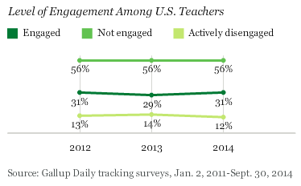

Implications

Gallup research has identified a number of outcomes associated with employee engagement, including teacher absenteeism estimated at more than 2.3 million additional missed workdays each school year. School leadership matters as well. Having principals with natural talent for their job enhances the likelihood that teachers will be engaged in their work. Engaged teachers are more likely to yield engaged students who realize greater educational achievement. Given these findings, the impetus to select and develop school principals and teachers based on their natural aptitudes for the role is paramount.
Engaged teachers in the U.S. enjoy a substantially higher level of purpose well-being compared with their less-engaged colleagues. Among the nation's "engaged" teachers, 74% are thriving in purpose well-being, compared with just 35% and 12%, respectively, among "not engaged" or "actively disengaged" educators.

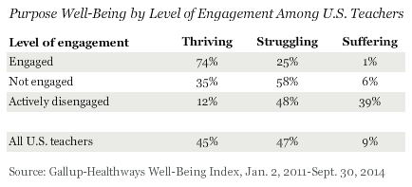

Overall, less than half of U.S. teachers -- just 45% -- are thriving in purpose well-being, with the majority (56%) struggling or suffering. These findings are consistent with estimates of well-being for the U.S. population more generally, measured as a part of the Gallup-Healthways Well-Being Index. Worldwide, just 18% of adults are thriving in purpose well-being, while in the U.S. this rate increases to 37% thriving.

At 98% -- almost universally -- engaged teachers agree or strongly agree that they use their strengths to do what they do best every day. In contrast, just 40% of actively disengaged teachers report the same -- a more than 50-percentage-point difference -- with almost one-quarter disagreeing or strongly disagreeing that they get to use their strengths in this way every day.
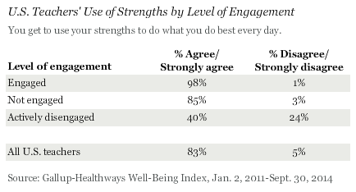

Again, with near universality, 98% of teachers who are engaged in their jobs agree or strongly agree with the statement, "You like what you do every day." This is eight points higher than the 90% rate of agreement found among not-engaged teachers, and 45 points higher than is true for the nation's actively disengaged teachers.

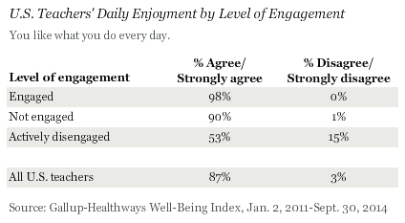

Seventy-six percent of engaged teachers report having reached most of their goals over the past year, compared with just 35% of actively disengaged teachers and 63% of all U.S. teachers.
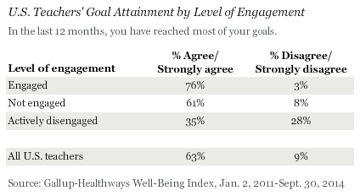

In addition to the personal benefits reported above, engaged teachers overwhelmingly identify a positive leader in their lives. In fact, 85% of engaged teachers agree or strongly agree with the statement, "There is a leader in your life who makes you enthusiastic about the future." Comparatively, only 37% of actively disengaged teachers and 67% of all U.S. teachers report the same.

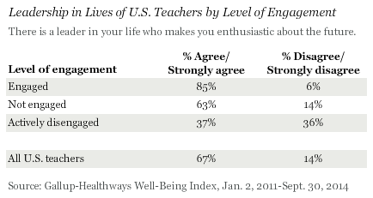
Implications

Teachers who are engaged in their jobs enjoy a personal and professional edge compared with their less-engaged colleagues across a range of purpose metrics. In a profession plagued with turnover rates approaching 15% to almost 20% for teachers employed at high-poverty schools, the positives associated with teacher engagement cannot be overlooked.

In addition to the individual benefits of an engaged teacher workforce, positive outcomes have been traced to students whom teachers serve, as well as the school systems where they work. Gallup's report on the State of America's Schools highlights a link between teacher engagement and student engagement -- and thereby, student achievement. Additionally, a recent Gallup article indicates that the lack of engagement among U.S. teachers results in more than 2.3 million additional missed workdays every year. As such, unengaged educators are likely to affect school budgets in terms of substitute teacher costs, and school success via their classroom absence.

Engagement can serve as a key lever for enhancing well-being, and vice versa. Schools that prioritize both of these as part of teacher professional development efforts might expect a substantial return on their investments, including reduced attrition, daily stress, and use of healthcare services.

